Sarah Merrell
Motorcycle Rider, Writer, Blogger & Influencer

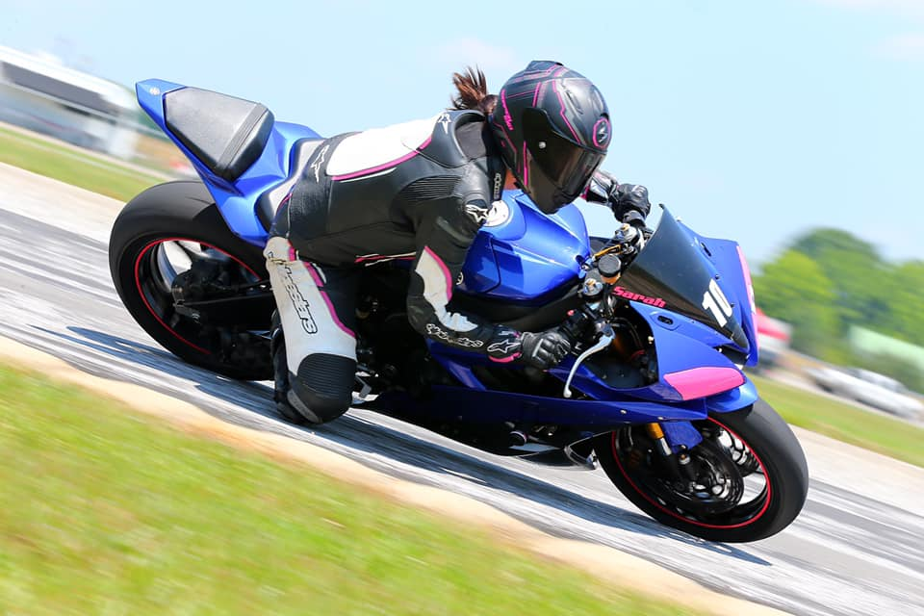

Hi, I’m Sarah.
I share my passion for motorcycling and adventures on the road and track through my motorcycle blog, social media account and by writing for motorcycle publications. I began riding a little over 10 years ago and today my life revolves around this sport. I live in the Smoky Mountains on the Tennessee and North Carolina border and the infamous and world-renowned motorcycling road, The Dragon (US Highway 129), is my home turf. On any given weekend you can find me tearing up the mountain roads. I’m also hooked on track days and do them every chance I get and also hone my skills through instruction like Yamaha Champions Riding School and advanced rider courses. Recently I’ve started traveling to ride roads all across the U.S. and I’m always on the lookout for races and motorsports events to attend.
Growing the number of women riders in the sport and supporting women riders is important to me. I serve as the National Marketing Director for Women’s Sportbike Rally—an event that has helped grow the sport among women. Now that I’ve become a more experienced, confident and safe rider, I enjoy helping other women by leading guided rides, offering mentorship and serving as a source of motivation and support.
This sport is very special to me and I want to see more people experience the utter joy, thrill and serenity that comes from motorcycle riding. I hope to help achieve that through my blog, social media and writing. Through these outlets, I love sharing riding tips, places and events to visit and I try out products and bikes and review them.
When I’m not riding my Yamaha R6 or Suzuki DRZ Supermoto, I race pit bikes through a mini bike racing series. My goal is to start racing my R6. The future looks bright, and I hope we can collaborate.
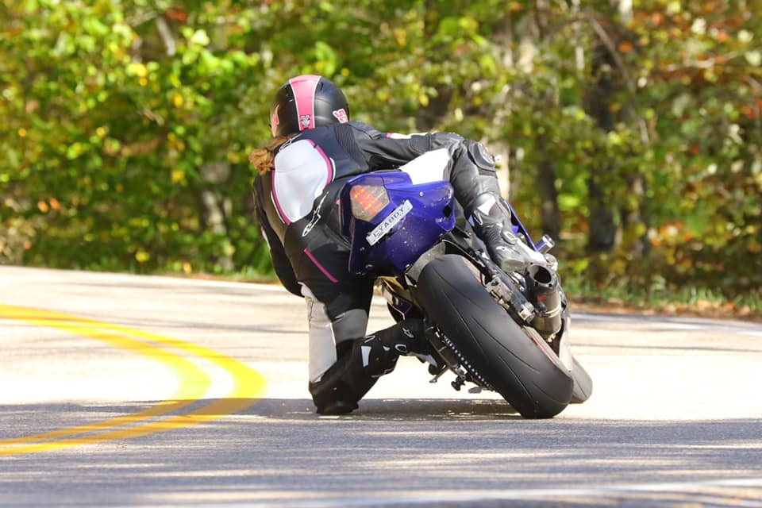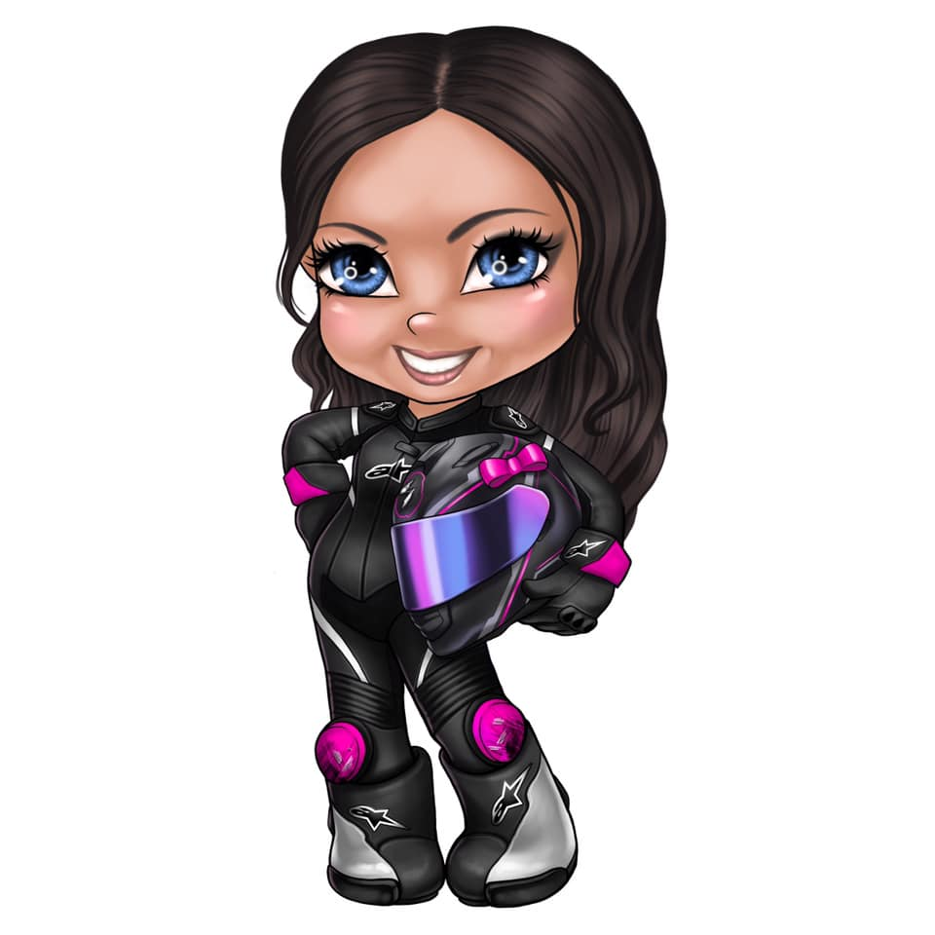

My Motorcycling Resume:
- Editor at Large for Blue Ridge Motorcycling Magazine
- 2019 Yamaha Champions Riding School Grad
- 2009 Motorcycle Safety Foundation Certificate
- Completed Total Rider Tech Course
- Avid Track Day Enthusiast – Receives Coaching at Track Days
- Women’s Sportbike Rally National Marketing Director
- Women’s Sportbike Rally Advanced Ride Leader
- Fiddies 4 Life Pit Bike Racer
Key Brands I’ve Worked With:

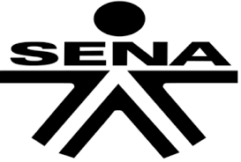

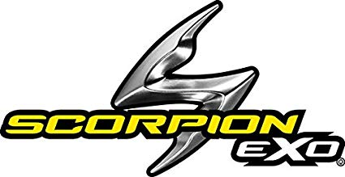

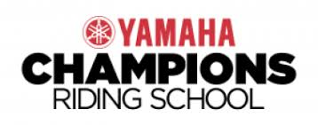
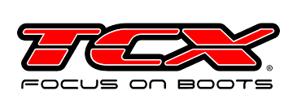

There are many motorsports influencers out there, but these are 9 reasons why I’m different…
1. I work in marketing an public relations
I’ve been working in marketing and PR for over 10 years and possess expertise in social media content development. I manage social media for many of my clients, and utilized my knowledge of digital marketing to grow my own social media following. I understand the importance of storytelling, brand voice and how to create content that resonates with targeted audiences.
2. I know how to create content people will engage with
When I work with a brand as influencer, they can have the peace-of-mind that the content I create—whether for my blog or social media—will be compelling. I take great care in making sure any photos and videos are excellent and fine tune any copy that I write for the posts or blog.
3. I’m a writer
Through my degree in communication studies and my work in marketing and PR, I’ve learned how to write and have used that expertise to write for various publications in my spare time. Plus, I can write about your brand in the publications I work with.
4. My content isn’t just “eye candy”
Sure, I post some pictures of myself modeling with my bike or the gear I’m reviewing, but a majority of my content isn’t just modeling. I write and post content that I hope will motivate people to be passionate about motorsports and I also promote the importance of skills and safe riding. I write about what I learn from track days and schools, and I love sharing my experiences at motorcycle events or trying out different gear and bikes. I seek to create content with substance.
5. I provide a way to effectively reach female riders
If you’re looking to tap into the female riding community, I’m your woman. I’m highly involved with Women’s Sportbike Rally and serve as part of their leadership and also lead their advanced rides. Through the rally, I serve as a mentor to women riders—especially ones who are new. I also post blogs directly targeted to women to help them progress in the sport. Plus, I have a solid following of women riders on social media who consistently ask me for gear recommendations or purchase the gear that I use.
6. I live at one of the top motorcycle destinations in the world
I live near The Dragon (highway 129) and ride there nearly every weekend unless I’m at a track day or motorcycle event. Tens of thousands of people come through The Dragon each season. I meet motorcyclists from all walks of life and it’s given me the chance to connect with many people. Plus, the dozen photographers situated along The Dragon ensure I always have fresh riding photos.
7. I’m visible in the industry
I try to attend as many motorcycle events and track days as possible to stay up-to-date but also accumulate ontent for social media. Through these events, I develop connections and work on collaborations—or sometimes I just go and enjoy the track and build my skill set.
8. I’m professional
As an influencer and someone who is active in the industry and maintains a social media following, I find it important to be a good representative for the brands I work with. I take my influencer work seriously and seek to be reliable and follow through on agreements. I refrain from posting controversial or unclassy content.
9. I go above and beyond
I believe in providing added value for the brands I work with, so I do more than just the bare minimum.

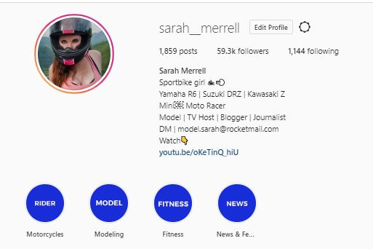
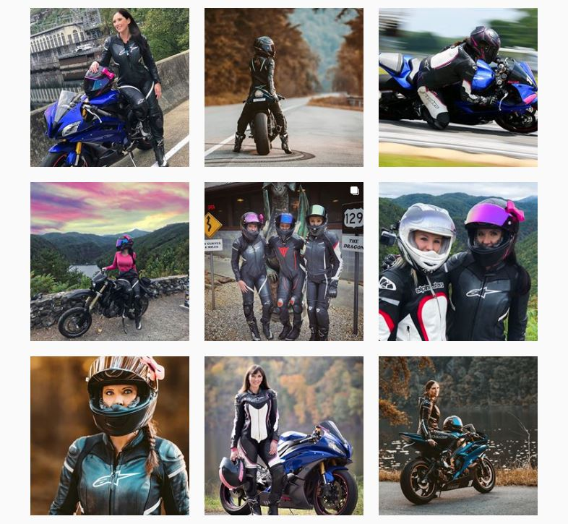

Where You’ve Seen Me

Blue Ridge Motorcycling Sportbikes Inc Magazine
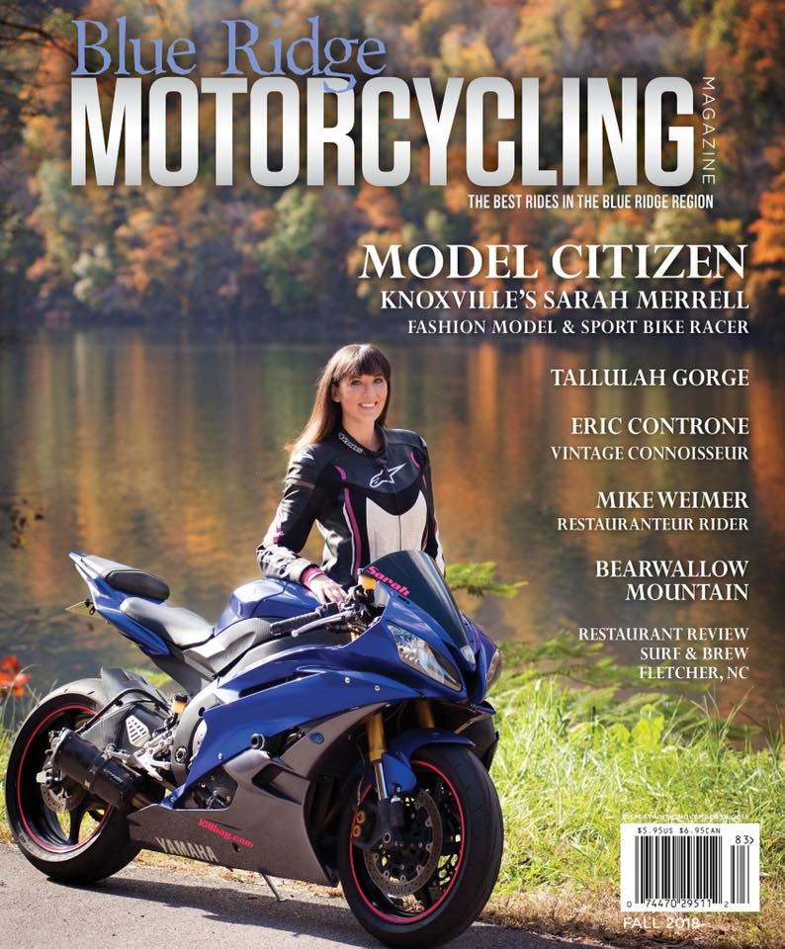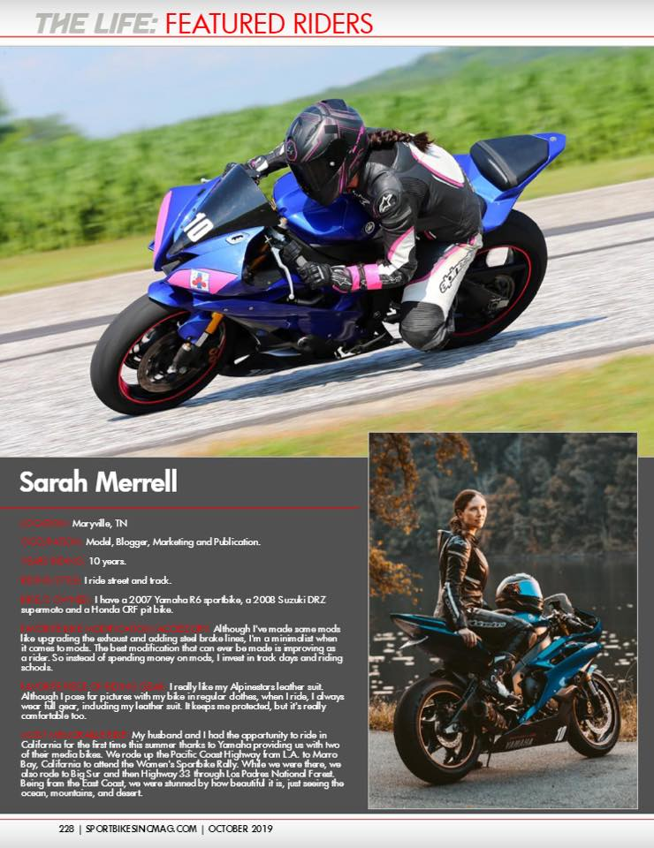

You Motorcycle Interview Tech ‘N Wheelz Interview
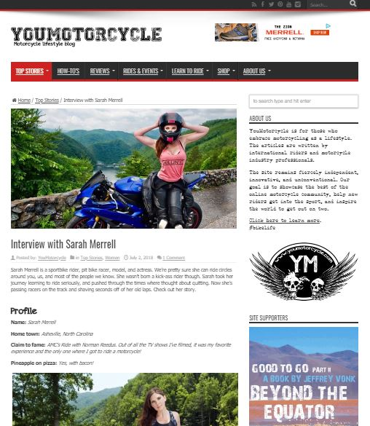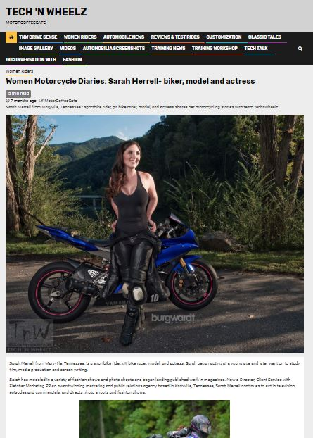

My SportbikeSweetheart.net Blog

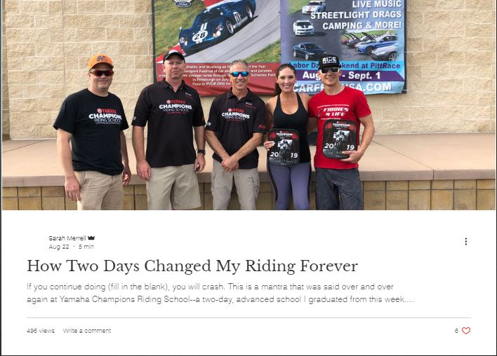
Types of Blog Topics I’ve Covered:
- Motorcycle Travel – Covering Routes & Roads
- Motorcycle Events & Track Days
- Motorcycle Reviews
- Gear Reviews
- Skill and Safety Tips
- Riding The Dragon & Smoky Mountains
- Tips and Content for Women Riders
- New Product Launches

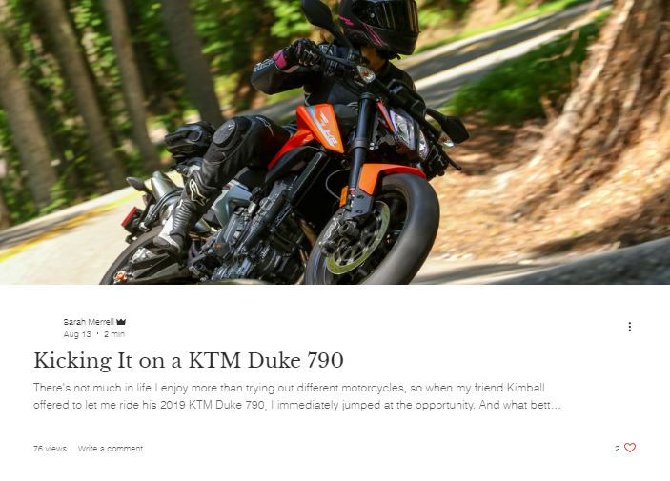
My Blog Posts Are Often Re-published Through Motorcycle Magazines! And I’ve had motorcycle industry experts like Nick Ienatsch serve as collaborators.

Motorsports Modeling, Acting and Spokesperson Work
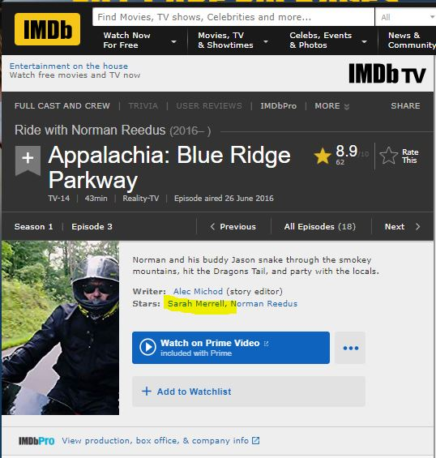

In 2016, I appeared alongside Norman Reedus for the TV show “Ride with Norman Reedus” on AMC. The TV show filmed the pit bike racing that I do and I introduced Norman to Deals Gap Motorcycle Resort.
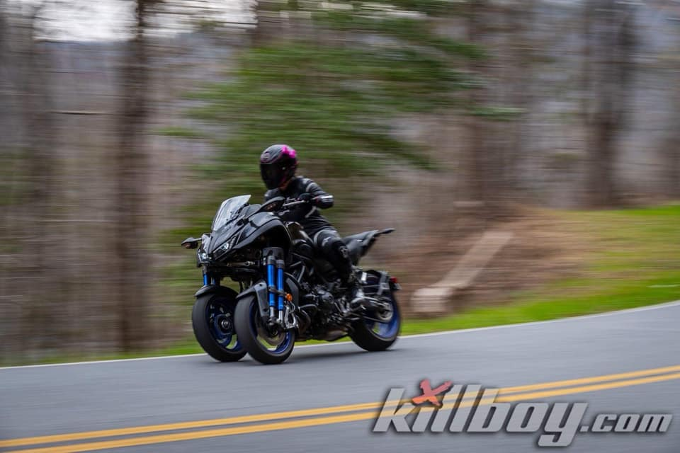
I have also done the following:
- Photo and video shoot on the Yamaha Niken for Wolf Creek Rentals
- Photo and video shoot for Royal Enfield
- Video review for Viking Cycles
- Interview video with Yamaha Champions Riding School
- Interview for famed motorcycle racer, author and coach Nick Ienatsch’s podcast
- Social media photo/video collaboration with Yamaha Motor USA
- Photography for Ride Like a Girl Racing
- Interview on Life in the Fast Lane podcast
- Participated in 2020 Triumph Immersion influencer event
Modeling, Acting and Spokesperson Work
My experience as a model and actress and working in television has provided me with a set of skills that has aided me in my work as an influencer. In the past I’ve been a signed model with Gage Models & Talent Agency and did numerous photo shoots and TV commercials. Because of this, I’m very comfortable and confident in front of the camera. I also have experience working as an on-air reporter and news correspondent.
Examples of my modeling and acting work:

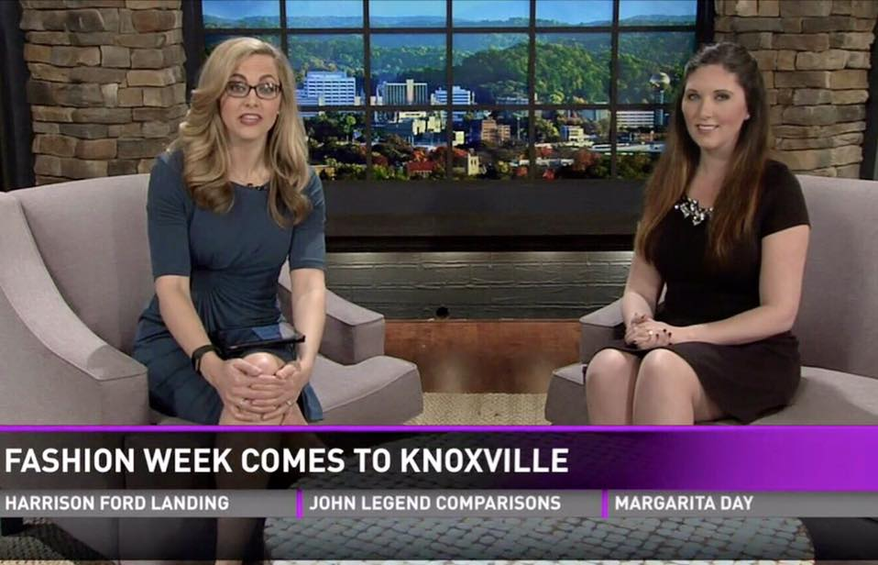
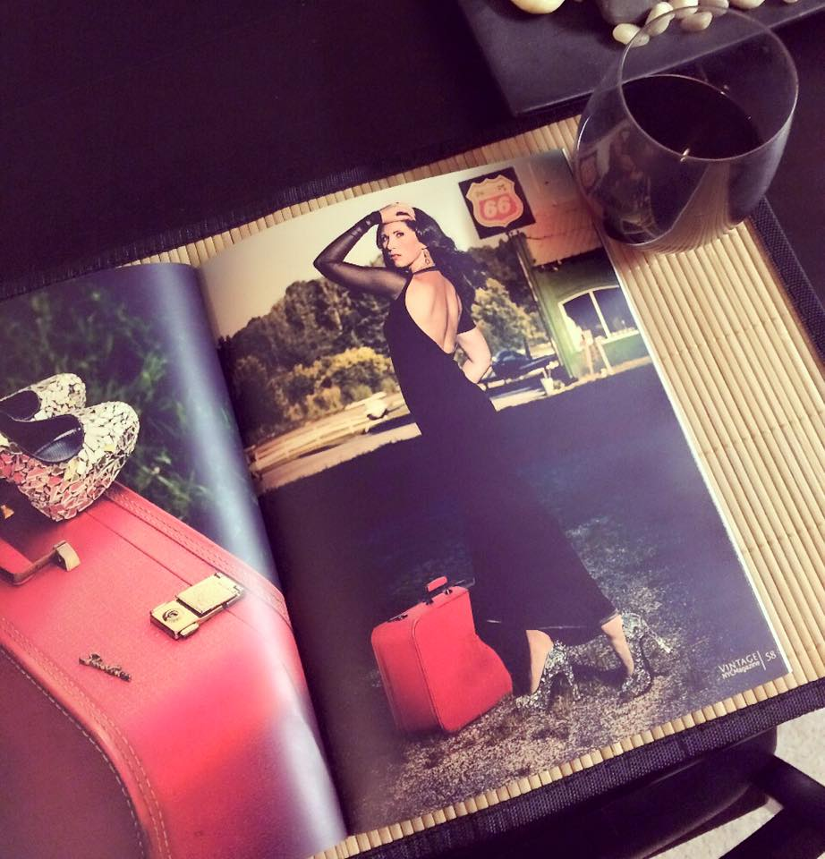
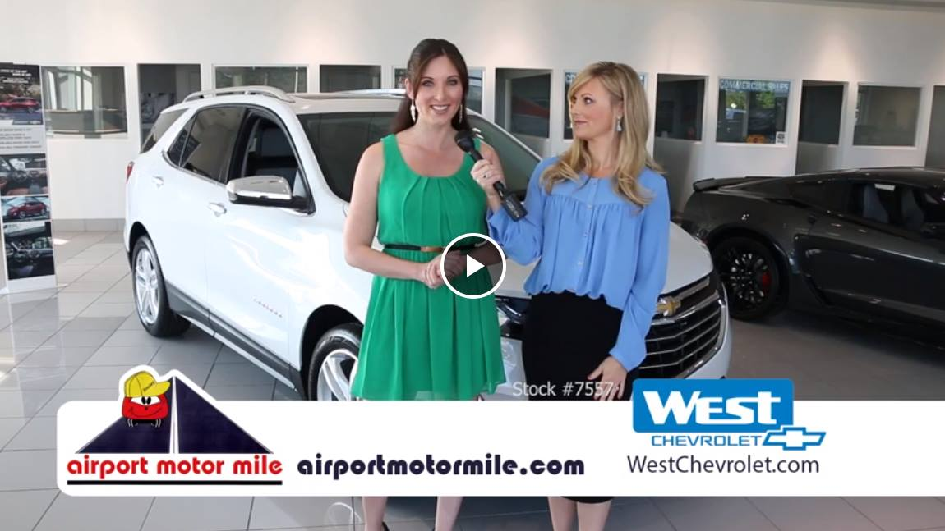

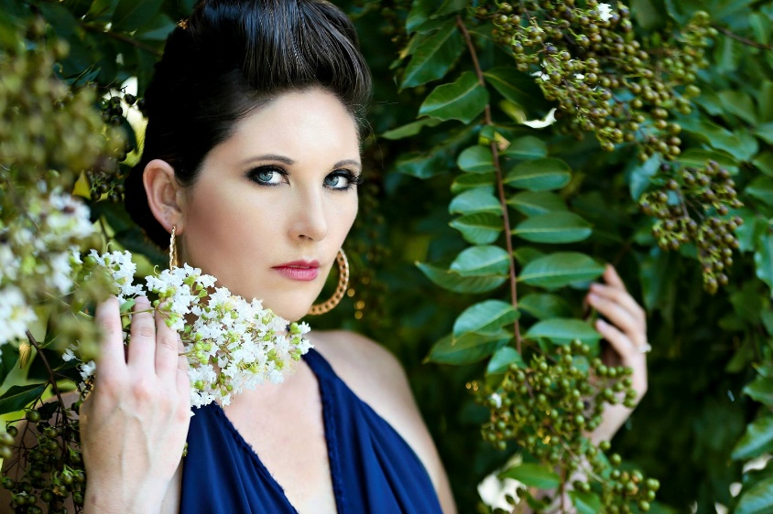

Honors, Awards, Degrees & Certifications
Motorcycling:
- Michelin Road 5 Slick Award
- Yamaha Champions Riding School Grad
- Motorcycle Safety Foundation Course
- Total Rider Tech Advanced Riding Course Grad
- Lots and Lots of Track Days!
- Fiddies for Life Pit Bike Race Series:
- Powder Puff Champ 2 years in a row
- 2nd Place Overall – 2017
- 3rd Place Overall – 2018
Business:
- Top 40 Under 40 Young Professional – Knoxville, 2019
- Top 40 Under 40 Young Professional – Asheville, 2012
- Young Professional of the Year Finalist – Knoxville, 2017
- Celebrity Dancer – Dancing for the Horses – Knoxville, 2019
- Goodwill Special Recognition Award for Community Service – Winston Salem, 2018
- Gritty Award for Best Fashion Writing – 2015
- Featured Western Carolina University Alumni Success Story
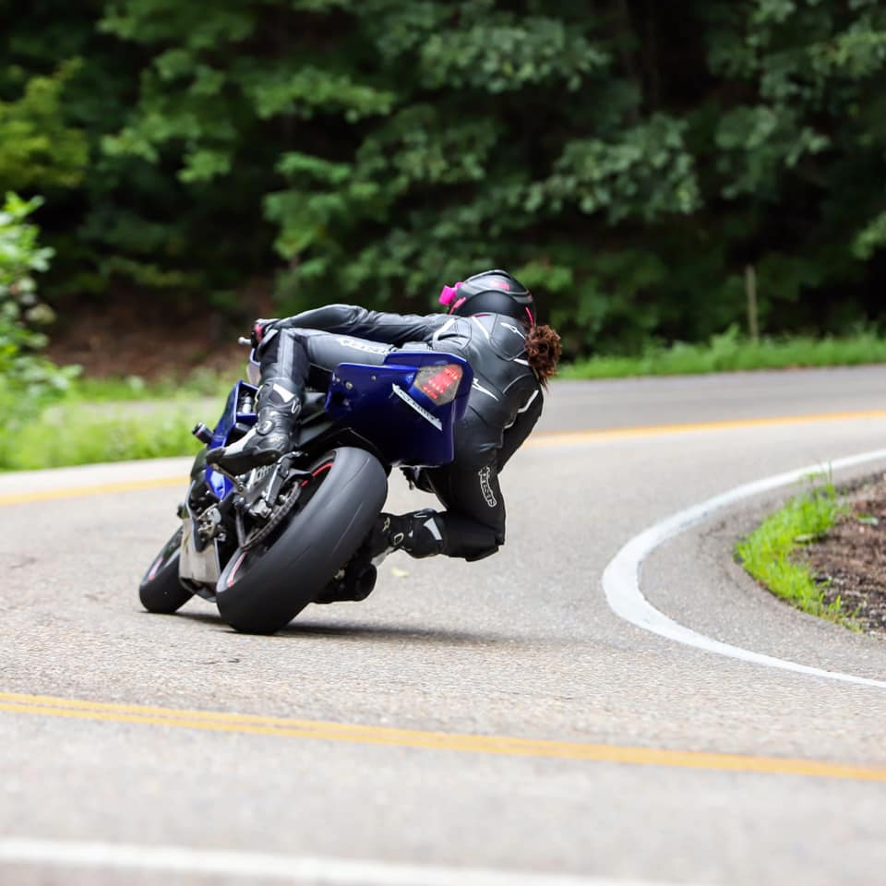
Degrees & Certifications:
- UNC Chapel Hill – BA Communication Studies
- Western Carolina University – Master of Business Administration
- Hubspot Inbound Marketing Certified
- Hubspot SEO Course Grad

Writing:
- Editor at Large for Blue Ridge Motorcycling Magazine (current)
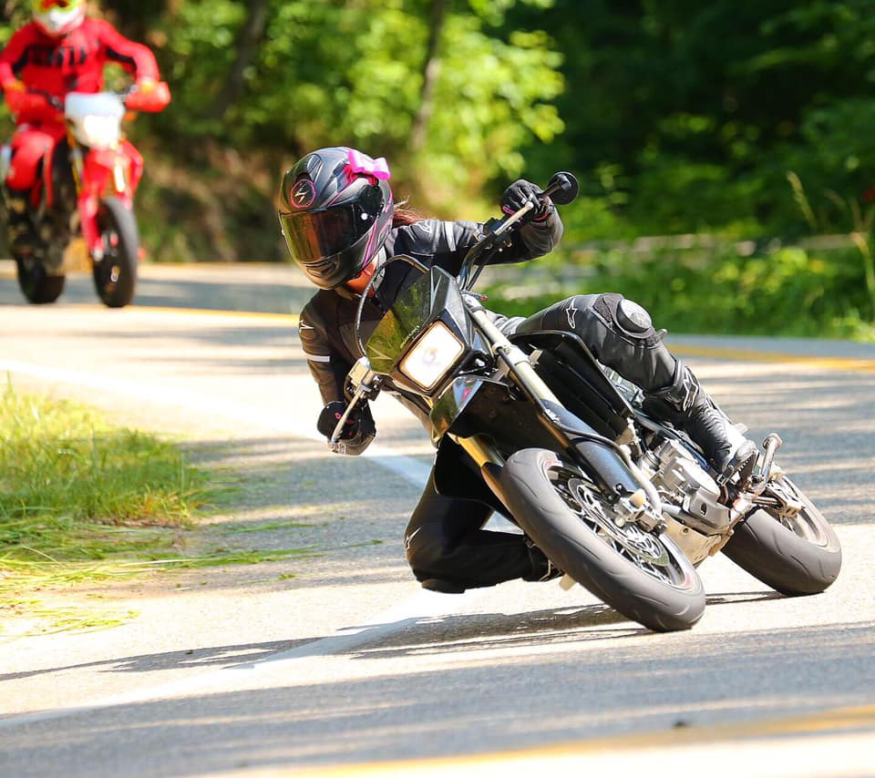
- Fashion Coordinator and Writing – Sophie Magazine (2018 – 2019)
- Fashion Columnist – HUSHH Magazine (2015 – 2018)
- Fashion Columnist – Mountain Style Magazine
- Asheville Grit – Fashion Writer

I hope you’ll give me the opportunity to work with your brand. I’m open to a variety of different types of collaboration. These are some examples of what I’ve done with other brands:
- Social media takeovers
- Guest blogging
- Promoting or review products or social media or through my blog
- Video reviews or product promotions
- Spokesperson work
- Trade show model or spokesperson
- TV commercials and video filmings
- Podcast interviews
- Attending events and serving a model or spokesperson
- Modeling products or services in a photo shoot
- Writing articles or news releases for publication or pitching to the media
- Marketing and public relations services and consulting
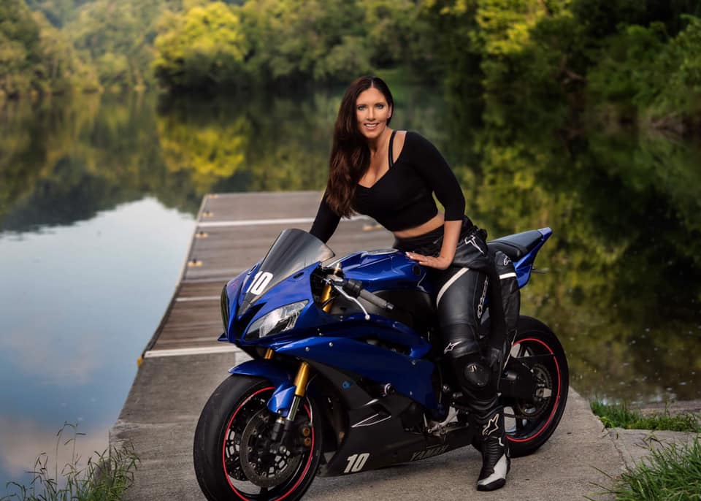
CONTACT ME
828.231.3963
Model.sarah@rocketmail.com
SportbikeSweetheart.net
